Acrylic Table Bases and Glass Tops

We offer a complete assembly of acrylic table bases and glass tops – easy for you to set up in your home.
Ordering is easy: Simply confirm the details you want for the acrylic table bases and the glass top and we will provide a quote for your complete assembly.

1” thick acrylic table bases

- We recommend a set of 3 bases as shown in the illustration below. Each semi-circular acrylic base will have a diameter of 30” and a depth of 16” which assures stability.
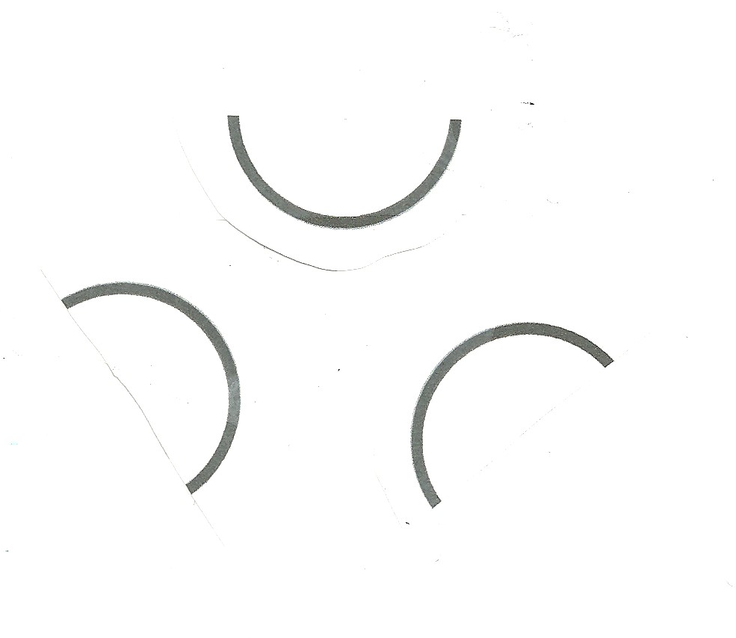
- You simply tell us your desired height of the acrylic bases. We recommend a 30” height which, when added to the ½” thickness of the glass top, will provide a tabletop height of 30 ½”.

- Pricing: Retail price for a set of 3 acrylic bases is $2,996. Designer or Stocking Wholesale price is $2,247. Each additional acrylic piece (if 4 are desired) is $980 (Retail) and $735 (Designer/Stocking Wholesale).

Glass top for acrylic table bases

- We recommend a 72” diameter glass top made from ½” thick tempered glass. Edges can be either a 1” beveled edge or a non-beveled edge. Other top diameters are available and rectangular sizes are available as well.

- Simply confirm the details of the glass top you want and we will provide pricing.

